Bài 3

3.1:
1. Control Flow Graph (CFG)
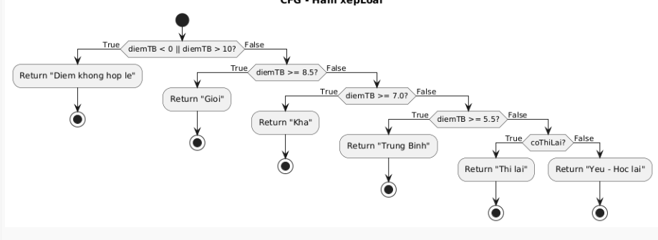
2. Statement Coverage
Các statement cần chạy
return "Diem khong hop le"
return "Gioi"
return "Kha"
return "Trung Binh"
return "Thi lai"
return "Yeu - Hoc lai"
Tổng: 6 statements
Test case tối thiểu:
TC | diemTB | coThiLai | Đường đi CFG | Kết quả
TC1 | -1 | false | N1(T) | Diem khong hop le
TC2 | 9 | false | N1(F) → N2(T) | Gioi
TC3 | 7.5 | false | N1(F) → N2(F) → N3(T) | Kha
TC4 | 6 | false | N1(F) → N2(F) → N3(F) → N4(T) | Trung Binh
TC5 | 4 | true | N1(F) → N2(F) → N3(F) → N4(F) → N5(T) | Thi lai
TC6 | 4 | false | N1(F) → N2(F) → N3(F) → N4(F) → N5(F) → N6 | Yeu - Hoc lai
Statement Coverage:
Executed statements = 6
Total statements = 6
Statement Coverage = 6/6 = 100%
3. Branch Coverage
Tổng số điều kiện
Có 5 điều kiện:
Node1
Node2
Node3
Node4
Node5
Mỗi điều kiện có True + False: Total branches = 5 × 2 = 10
Branch | Mô tả | TC phủ
N1 True | diemTB <0 hoặc >10 | TC1
N1 False | 0 ≤ diemTB ≤10 | TC2-6
N2 True | >= 8.5 | TC2
N2 False | < 8.5 | TC3-6
N3 True | >=7 | TC3
N3 False | <7 | TC4-6
N4 True | >=5.5 | TC4
N4 False | <5.5 | TC5-6
N5 True | coThiLai=true | TC5
N5 False | coThiLai=false | TC6
Branch Coverage:
Covered branches = 10
Total branches = 10
Branch Coverage = 10/10 = 100%
- Code TestNG (Branch Coverage)
public class XepLoai {

public static String xepLoai(double diemTB, boolean coThiLai) {
if (diemTB < 0 || diemTB > 10) {
return "Diem khong hop le";
}
if (diemTB >= 8.5) {
return "Gioi";
} else if (diemTB >= 7.0) {
return "Kha";
} else if (diemTB >= 5.5) {
return "Trung Binh";
} else {
if (coThiLai) {
return "Thi lai";
}
return "Yeu - Hoc lai";
}
}
}
TestNG Test Class:
import org.testng.Assert;
import org.testng.annotations.Test;

public class XepLoaiTest {

@Test
public void testDiemKhongHopLe() {
Assert.assertEquals(XepLoai.xepLoai(-1, false), "Diem khong hop le");
}

@Test
public void testGioi() {
Assert.assertEquals(XepLoai.xepLoai(9, false), "Gioi");
}

@Test
public void testKha() {
Assert.assertEquals(XepLoai.xepLoai(7.5, false), "Kha");
}

@Test
public void testTrungBinh() {
Assert.assertEquals(XepLoai.xepLoai(6, false), "Trung Binh");
}

@Test
public void testThiLai() {
Assert.assertEquals(XepLoai.xepLoai(4, true), "Thi lai");
}

@Test
public void testYeuHocLai() {
Assert.assertEquals(XepLoai.xepLoai(4, false), "Yeu - Hoc lai");
}
}

